Our ref: TPS/3247
Enquiries: Local Planning Schemes
Email: localplanningschemes@dplh.wa.gov.au
Chief Executive Officer
Shire of Murray
PO Box 21
PINJARRA WA 6208

Transmission via electronic mail to: mailbag@murray.wa.gov.au

Dear Sir/Madam

SHIRE OF MURRAY LOCAL PLANNING SCHEME NO. 4 AMENDMENT NO. 322

The Western Australian Planning Commission (Commission) has considered the amendment and submitted its recommendation to the Minister in accordance with section 87(1) of the Planning and Development Act 2005 (the Act).

The Minister has approved the amendment in accordance with section 87(2)(a) of the Act.

In accordance with section 87(3) of the Act, the Commission will cause the approved amendment to be published in the Government Gazette.

The Commission has forwarded notice to the Department of Premier and Cabinet (attached) and it is the local governments' responsibility to make arrangements for the payment of any publication costs. The local government is required under section 87(4B) of the Act, and regulation 64 of the Planning and Development (Local Planning Schemes) Regulations 2015, to publish the approved amendment, ensure that it is available to the public, and notify each person who made a submission.

For all payment and purchase order queries, please contact the Department of Premier and Cabinet on (08) 6552 6000. One signed set of the amending documents are returned for your records.

Please direct any queries about this matter to localplanningschemes@dplh.wa.gov.au

Yours sincerely

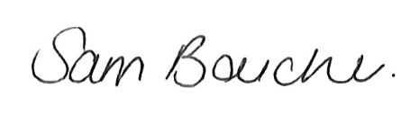

Ms Sam Boucher
Secretary
Western Australian Planning Commission

19/05/2026

